- According to Document #1, in 2013 how much student debt did the average public law school graduate have? What might have made this amount even higher?

- According to Document #2, how much student debt does a new teacher with a Masters Degree in Education have upon graduation in 2012?

- How many years on average does a teacher have to devote to their education including graduate school? How long for a Lawyer?

- According to Document #3 How much does a beginning lawyer make per year?

- How much does a beginning teacher make per year?

- How many days in a 365-day year do teachers work?

- If a beginning lawyer has two weeks of vacation per year and all federal holidays off, how may days per year does a lawyer work?

- How much does a beginning teacher make per day?

- How much does a beginning lawyer make per day?

- If a teacher worked the same number of days that a beginning lawyer does and is paid extra for all the days that are added on to their work year, what would this adjusted yearly salary be for a beginning teacher?

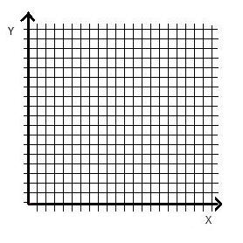
GRAPH TITLE: ________________________________________________________________

GRAPH #2
Create a bar graph that compares data from question 4 and 10
Or
Create a bar graph that compares data from question 8 and 9
GRAPH TITLE: ________________________________________________________________
GRAPH #1
Create a bar graph that compares data from question 1 and 2
Or
Create a bar graph that compares data from question 4 and 5

